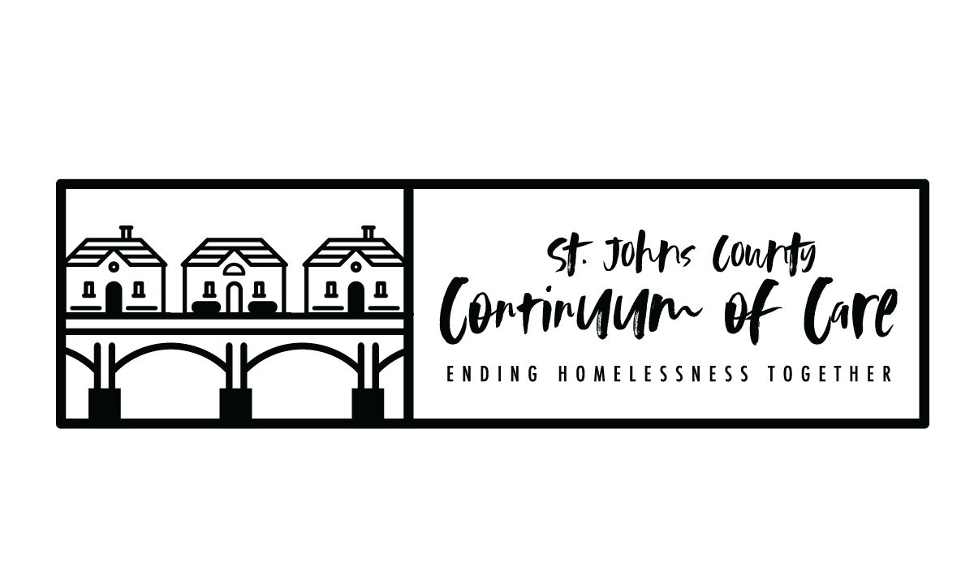
Task | Date
NOFO Released by HUD | WEDNESDAY 6/22/22
General Membership Meeting – funding opportunity planning announcement, LOI process released. | WEDNESDAY 8/10/22
Score card and policy/procedures sent to Board for review | WEDNESDAY 8/31/22
Board feedback/vote on score card/policies/procedures | MONDAY 9/5/22
Local Application Public Release | TUESDAY 9/6/22
Project Applications due to CoC, via esnaps.hud.gov (LOCAL COMPETITION DEADLINE) | TUESDAY 9/20/22 by 8:00pm
Scoring and Review Committee application review | WEDNESDAY 9/21/22 –  TUESDAY 9/27/22
Scoring and Review Committee meeting to rank project applications and finalize Priority Listing | WEDNESDAY 9/28/22
CoC Board to approve rankings and Priority Listing | MONDAY 10/3/22
Project Applicants notified in writing of application rankings, rejections, reductions. Priority Listing available for distribution and public posting. | WEDNESDAY 10/5/22
CoC Consolidated Application submitted in e-snaps and posted publicly to the CoC website two days prior to the HUD Program Competition deadline. | TUESDAY 10/18/22 by 8:00pm
HUD Program Competition Deadline for CoC Consolidated Application and Priority Listing in e-snaps. | THURSDAY 10/20/22 by 8:00pm
FR-6500-N-25S
Continuum of Care Supplemental to Address Unsheltered and Rural Homelessness
Department of Housing and Urban Development

- PROJECT APPLICATION: All project applications are required to be submitted to the CoC (esnaps.hud.gov) no later than 30 days before the consolidated application deadline (9/20/22).

- NOTIFICATION TO PROJECT APPLICANTS: The notification of the action (ranking, rejection or reduction) must be sent to all project applicants at least 15-days prior to the HUD consolidated application submission deadline for all project applications submitted to the CoC in the local competition.

- Public Notification of Ranked Project Applications: The notification of action that all project applicants who submitted project applications in the local CoC competition are notified at least 15-days prior to the HUD consolidated application submission deadline, this notification includes the ranked positions of the project applications. This notification will be posted publicly, as well as sent via email to individual project applicants.

- PUBLIC POSTING OF CONSOLIDATED APPLICATION: Will post on website, two days before the CoC Program Competition application submission deadline, all parts of the CoC Consolidated Application, including the CoC Application attachments and the Priority Listing, and notify community members and key stakeholders that the CoC Consolidated Application is available (Tuesday 10/18/22).

