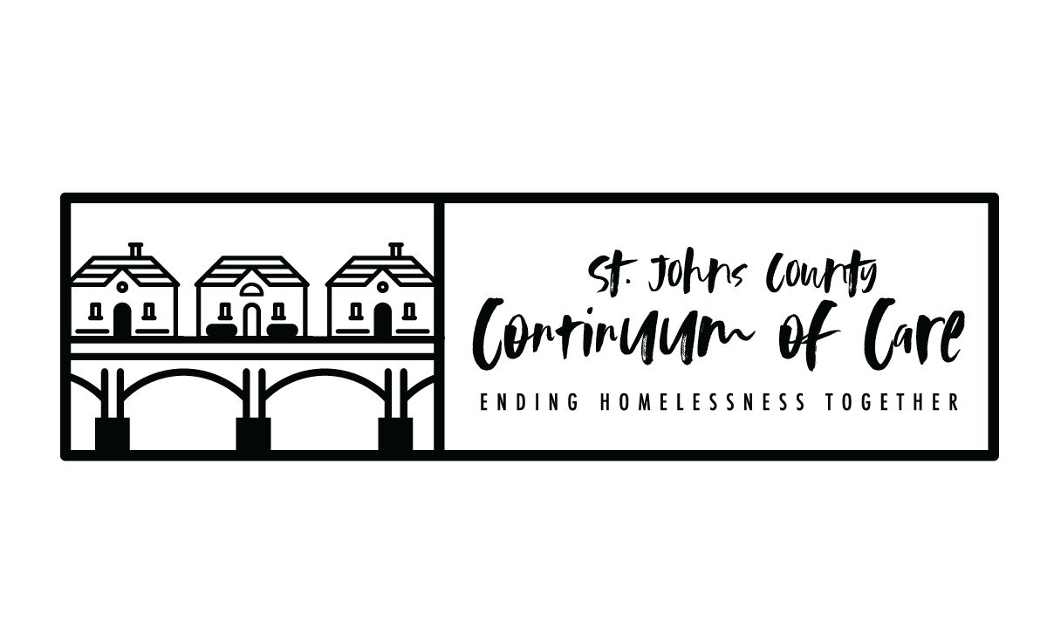
FY2023 CoC Program NOFO Timeline - FR-6700-N-25
Task | Date
NOFO Released by HUD | WEDNESDAY 7/5/23
General Membership Meeting – funding opportunity planning announcement, information session not yet scheduled | WEDNESDAY 7/12/23
Information session Save the Date sent, via email, to general membership and shared to SJC CoC Facebook page and website | FRIDAY 7/14/23
Local Project Application Public Release | THURSDAY 7/20/23
FY23 NOFO Info Session for interested applicants | FRIDAY 7/21/23
Score cards and policy/procedures sent to Board for review | WEDNESDAY 7/26/23
Board feedback/vote on score card/policies/procedures | WEDNESDAY 8/02/23
Project Applications due in E-Snaps (LOCAL COMPETITION DEADLINE) | TUESDAY 8/29/23 BY 8:00PM
Scoring and Review Committee application review | WEDNESDAY 8/30/23 –  TUESDAY 9/5/23
Scoring and Review Task Force meeting to rank project applications and finalize Priority Listing | WEDNESDAY 9/6/23
Rankings and Priority Listing finalized and sent to Board for review | THURSDAY 9/7/23
CoC Board to approve rankings and Priority Listing | MONDAY 9/11/23
Project Applicants notified in writing of application rankings, rejections, reductions. Priority Listing available for distribution and public posting. | WEDNESDAY 9/13/23
Public Posting at least 2 days before the FY 2023 CoC Program Competition application submission deadline - all parts of the CoC Consolidated Application (CoC application, Priority Listing, project applications) | TUESDAY 9/26/23
Local Deadline for CoC Consolidated Application (CoC application, Priority Listing, project applications) in E-Snaps | TUESDAY 9/26/23
HUD Deadline for CoC Consolidated Application (CoC application, Priority Listing, project applications) in E-Snaps: https://esnaps.hud.gov/ | THURSDAY 9/28/2023 BY 8:00PM

- PROJECT APPLICATION: All project applications are required to be submitted to CoC no later than 30 days before the application deadline (8/28/23).

- NOTIFICATION TO PROJECT APPLICANTS: The notification of the action (ranking, rejection or reduction) must be sent to all project applicants at least 15-days prior to the HUD consolidated application submission deadline for all project applications submitted, via E-Snaps, to the CoC in the local competition.

- Public Notification of Ranked Project Applications: The notification of action that all project applicants who submitted project applications in the local CoC competition are notified at least 15-days prior to the HUD consolidated application submission deadline, this notification includes the ranked positions of the project applications. This notification will be posted publicly, as well as sent via email to individual project applicants. Proof of posting date/email date is necessary, via clear screenshots.

- PUBLIC POSTING OF CONSOLIDATED APPLICATION: Must post on SJC CoC website, at least 2 days before the FY 2023 CoC Program Competition consolidated application submission deadline, all parts of the CoC Consolidated Application, including: The CoC Consolidated Application, attachments, and the Priority Listing. Must notify community members (via website) and key stakeholders (website and email) that the CoC Consolidated Application is available (Wednesday 9/26/23).

- The CoC Application and the FY 2023 CoC Priority Listing are separate submissions in E-Snaps; therefore, Collaborative Applicants must ensure both the CoC Application and the
FY 2023 CoC Priority Listing, that includes all project applications either approved and
ranked or rejected, are submitted in e-snaps prior to the CoC Program application
submission deadline.

