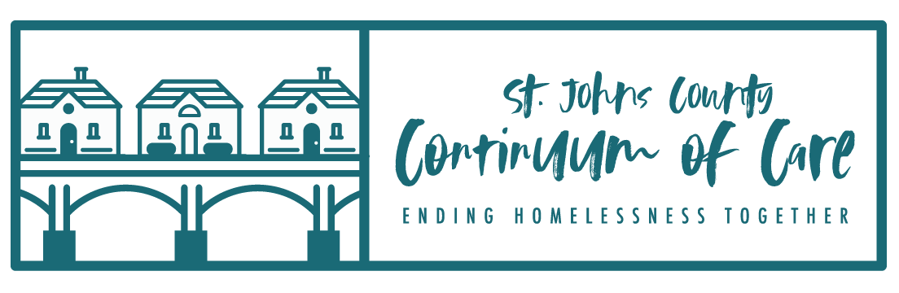

FY22 HUD NOFO CoC Competition

Instructions for Submission of Project Applications

Deadline – August 30th by 8:00pm in e-snaps

Instructions:

- Project applications must be submitted through e-snaps, the CoC Program Applications and Grants Management System (https://esnaps.hud.gov/grantium/frontOffice.jsf). For assistance in submitting your project application, please use the detailed instructions and navigational guide provided by HUD for your specific project type linked below.

- To ensure that your project is sent to the correct CoC through e-snaps, please make sure you identify FL-512 as your CoC (Screen 3A in both the New Project Application and the Renewal Project Application). By selecting FL-512 as your CoC, when you submit your project application, it will be forwarded directly to the Collaborative Applicant for review through e-snaps.

- Please complete and attach the supplemental questions for new projects and renewal projects.

- Please submit your project in e-snaps no later than the deadline above.

(NOTE: when you submit your project application in e-snaps, please utilize the “export to PDF” link to save and/or print a copy of your application for your records).

Please send a PDF copy of your project application electronically to Lindsey Rodea at Flagler Hospital – lindsey.rodea@flaglerhospital.org – no later than the deadline above.

HUD Guides for Project Applicants : FY 2022 Instructions not currently available via https://www.hud.gov/program_offices/comm_planning/coc/competition

Renewal Projects
• https://www.hud.gov/sites/dfiles/CPD/documents/FY-2021-Renewal-Project-Application-Detailed-Instructions.pdf

• https://www.hud.gov/sites/dfiles/CPD/documents/FY-2021-Renewal-Project-Application-Navigational-Guide.pdf

New Projects
• https://www.hud.gov/sites/dfiles/CPD/documents/FY-2021-New-Application-Detailed-Instructions.pdf

• https://www.hud.gov/sites/dfiles/CPD/documents/FY-2021-New-Project-Application-Navigational-Guide.pdf

Questions :

Questions about the CoC Program Competition must be submitted to the appropriate HUD.gov email address, as follows:

• CoCNOFO@hud.gov for questions about the NOFO, competition, and applications.

• e-snaps@hud.gov for questions about e-snaps technical issues, including creating an individual user profile, lockouts/password resets, requesting access to a CoC’s or project applicant’s e-snaps account, navigating e-snaps, updating the Applicant Profile, identifying the funding opportunity, creating a project, and accessing the application on the Submissions screen.

