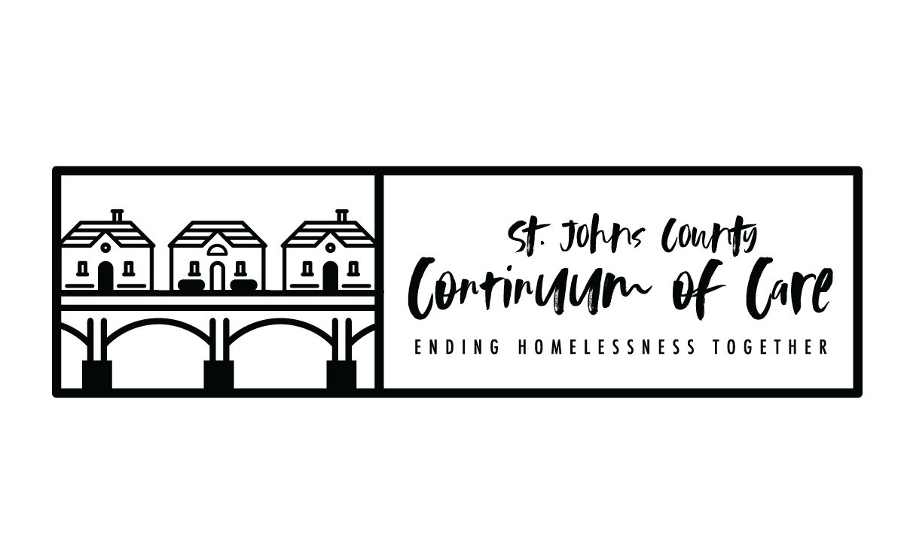

FY2019 CoC Program NoFA Timeline
Task | Date
NOFA Released by HUD | WEDNESDAY 7/3/2019
Round Table Discussion: ALL POTENTIAL APPLICANTS MUST ATTEND | MONDAY 8/5/2019
Project Applications due in E-snaps (DEADLINE) | FRIDAY 8/30/2019  5:00 pm
Scoring and Review Committee application review | TUESDAY 9/3/2019
Scoring and Review Committee meeting to rank project applications and finalize Priority Listing | MONDAY 9/9/2019
CoC Board and General Membership Meetings to approve rankings and Priority Listing | TUESDAY 9/10/2019
Project Applicants notified in writing of application rankings, rejections, reductions | THURSDAY 9/12/2019
CoC Consolidated Application and Priority Listing available (Distribution and Public Posting) | FRIDAY 9/13/2019
Local Deadline for CoC Consolidated Application and Priority Listing in e-snaps | THURSDAY 9/26/2019
HUD Deadline for CoC Consolidated Application and Priority Listing in e-snaps | MONDAY 9/30/2019  8:00PM

- PROJECT APPLICATION: All project applications are required to be submitted to CoC no later than 30 days before the application deadline (9/30/2019).
- NOTIFICATION TO PROJECT APPLICATNTS: Required to notify in writing “outside of e-snaps, all project applicants who submitted their project applications to the CoC by the CoC established deadline whether their project application will be accepted and ranked on the CoC priority listing, rejected or reduced by the CoC no later than 15 days of the FY 19 application deadline (9/30/2019).
- Consolidate application: CoC Application, Priority Listing, and project applications on behalf of CoC.
- Public Posting 2 days before the application submission deadline (All part of the consolidated application for transparency)(9/28/2019).

