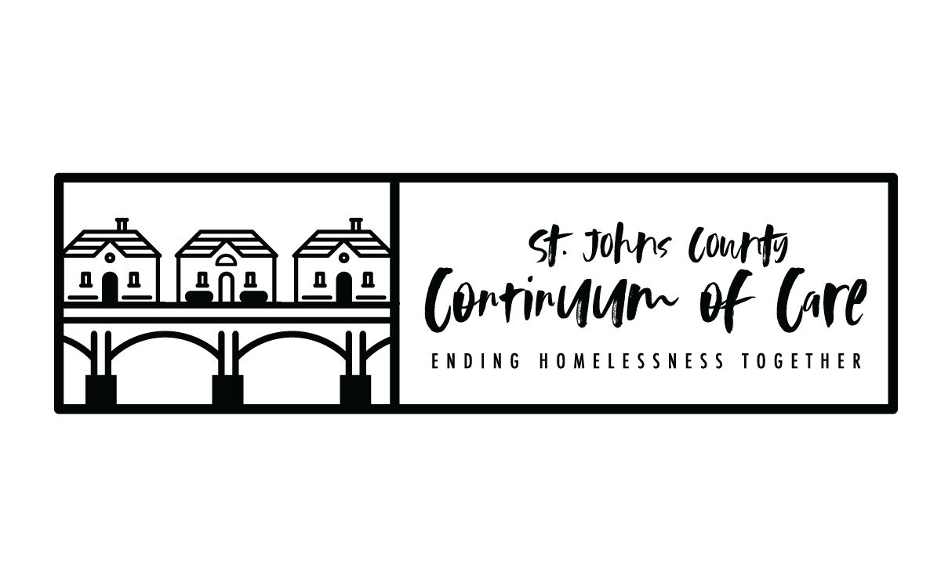
FY2022 CoC Program NOFO Timeline - FR-6600-N-25
Task | Date
NOFO Released by HUD | MONDAY 8/1/22
General Membership Meeting – funding opportunity planning announcement, information session scheduled | WEDNESDAY 8/10/22
Score card and policy/procedures sent to Board for review | FRIDAY 8/12/22
Board feedback/vote on score card/policies/procedures | MONDAY 8/15/22
Local Application Public Release | MONDAY 8/15/22
NOFO Info Session for interested applicants | TUESDAY 8/16/22
Project Applications due in E-Snaps (LOCAL COMPETITION DEADLINE) | TUESDAY 8/30/22 BY 8:00PM
Scoring and Review Committee application review | WEDNESDAY 8/31/22 –  TUESDAY 9/6/22
Scoring and Review Committee meeting to rank project applications and finalize Priority Listing | WEDNESDAY 9/7/22
Scoring and Review Committee recommendations sent to CoC Board for review | THURSDAY 9/8/22
CoC Board to approve rankings and Priority Listing | FRIDAY 9/9/22 BY 5:00PM
Project Applicants notified in writing of application rankings, rejections, reductions. Priority Listing available for distribution and public posting. | WEDNESDAY 9/14/22
Public Posting at least 2 days before the FY 2022 CoC Program Competition application submission deadline - all parts of the CoC Consolidated Application | WEDNESDAY 9/28/22
Local Deadline for CoC Consolidated Application and Priority Listing in  E-Snaps | WEDNESDAY 9/28/22
HUD Deadline for CoC Consolidated Application and Priority Listing in  E-Snaps | FRIDAY 9/30/2022 BY 8:00PM
- PROJECT APPLICATION: All project applications are required to be submitted to CoC no later than 30 days before the application deadline (8/30/22).

- NOTIFICATION TO PROJECT APPLICANTS: The notification of the action (ranking, rejection or reduction) must be sent to all project applicants at least 15-days prior to the HUD consolidated application submission deadline for all project applications submitted, via E-Snaps, to the CoC in the local competition.

- Public Notification of Ranked Project Applications: The notification of action that all project applicants who submitted project applications in the local CoC competition are notified at least 15-days prior to the HUD consolidated application submission deadline, this notification includes the ranked positions of the project applications. This notification will be posted publicly, as well as sent via email to individual project applicants.

- PUBLIC POSTING OF CONSOLIDATED APPLICATION: Must post on website, at least 2 days before the FY 2021 CoC Program Competition application submission deadline, all parts of the CoC Consolidated Application, including the CoC Application attachments and the Priority Listing, and notify community members and key stakeholders that the CoC Consolidated Application is available (Wednesday 9/28/22).

