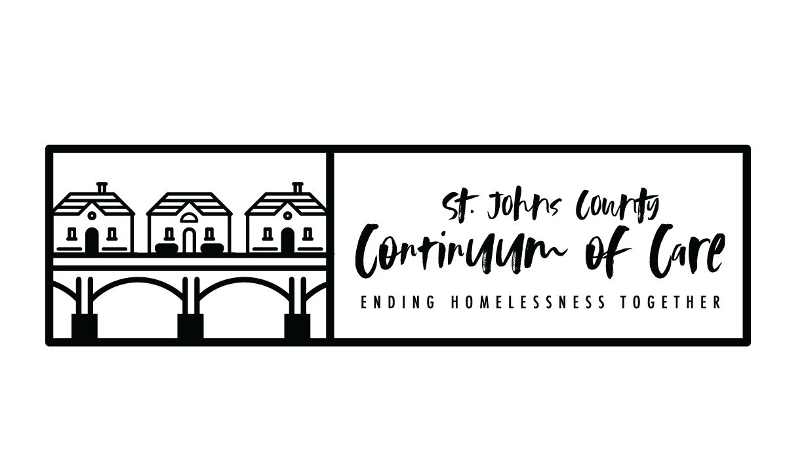
FY2021 CoC Program NOFO Timeline
Task | Date
NOFA Released by HUD | WEDNESDAY 8/18/21
Board and General Membership Meetings – timeline published, recruit scoring and review committee | WEDNESDAY 9/8/21
Score card and policy/procedures sent to Board for review | MONDAY 9/13/21
Board feedback/vote on score card/policies/procedures | WEDNESDAY 9/15/21
NOFO Info Session for interested applicants | THURSDAY 9/16/21
Local Application Release Date | FRIDAY 9/17/21
Project Applications due in E-snaps (LOCAL DEADLINE) | FRIDAY 10/15/21 5:00 pm
Scoring and Review Committee application review | TUESDAY 10/19/21-TUESDAY 10/26/21
Scoring and Review Committee meeting to rank project applications and finalize Priority Listing | TUESDAY 10/26/21
CoC Board to approve rankings and Priority Listing | WEDNESDAY 10/27/21
Project Applicants notified in writing of application rankings, rejections, reductions. Priority Listing available for distribution and public posting. | FRIDAY 10/29/21
Public Posting at least 2 days before the FY 2021 CoC Program Competition application submission deadline, all parts of the CoC Consolidated Application | FRIDAY 11/12/2021
Local Deadline for CoC Consolidated Application and Priority Listing in e-snaps | FRIDAY 11/12/2021
HUD Deadline for CoC Consolidated Application and Priority Listing in e-snaps | TUESDAY 11/16/2021  8:00PM
- PROJECT APPLICATION: All project applications are required to be submitted to CoC no later than 30 days before the application deadline (11/16/21).
- NOTIFICATION TO PROJECT APPLICATNTS: The notification of the action (rejection or reduction) that must be sent to the project applicant at least 15-days prior to the HUD application submission deadline, if a new or renewal project application was submitted to the CoC in the local competition and was rejected or had its funding request reduced as part of the CoC’s local process.
- Public Notification of Ranked Project Applications: The notification of action that all project applicants who submitted new and renewal project applications in the local CoC competition are notified at least 15-days prior to the HUD application submission deadline of the CoC’s acceptance that includes the ranked position of the project applications. This notification may be posted publicly or sent via email to individual project applicants.
- Must post on website, at least 2 days before the FY 2021 CoC Program Competition application submission deadline, all parts of the CoC Consolidated Application, including the CoC Application attachments and the Priority Listing, and notify community members and key stakeholders that the CoC Consolidated Application is available. (Sunday, 11/14 – moved up to Friday 11/12)

